ASSIGNMENT 1

Minh Nguyen

104309099

COS10026 – COMPUTER TECHNOLOGY INQUIRY PROJECT

Swinburne University of Technology

## Outline

Outline 2

Introduction 3

Overview 3

Objective 3

Web Accessibility 3

Website Content (HTML files) 7

Sitemap 7

Website pages 7

Home 7

Jobs 8

Apply 8

About 9

Enhancements 9

Website Style (CSS file) 9

Home 9

Jobs 11

Apply 13

About 14

Enhancements 16

Key Features 17

Contribution and Reflection 17

Conclusion 17

References 18

# Introduction

## Overview

In today's digital age, the development of websites has become a critical endeavor. This report will discuss a website's design and development process for our group, emphasizing accessibility, content organization, and style.

## Objective

The primary objective of this report is to offer a comprehensive insight into the website's intricate aspects, including its content, design, key features, and the challenges faced during its creation.

This report comprises several sections, including an introductory overview, a discussion of accessibility guidelines, an in-depth exploration of content and style, a spotlight on critical features, a reflective analysis of contributions and challenges, a prudent conclusion teeming with recommendations for future enhancements, and an optional appendix replete with supplementary information.

## Web Accessibility

Web accessibility is paramount in ensuring that digital platforms are inclusive and cater to users with diverse abilities. Throughout the website's development, adherence to the Web Content Accessibility Guidelines (WCAG) 2.1. was by following the making the website distinguishable: the provision of alt text for images, the use of semantic HTML tags, the enforcement of sufficient color contrast, the usage of relative font sizes like ‘em’ or ‘%’ to resize text in different platforms and content on Hover or Focus; navigable: link purpose (in context) and headings and labels; predictable: consistent navigation and identification; input assistance: error identification, labels or instructions and error suggestion and compatible: parsing. Clear and concise language was employed, and content was structured logically and intuitively to enhance user experience.

# Website Content (HTML files)

## Sitemap

## Website pages

### Home

The Home page is named index.html, which gives a brief overview of the company's products and awards and a notice about job positions that the company has currently been looking for cyber security specialist, business analyst, and IT consultant. At the end of the body, we leave two links to the job description page and the application form page if anyone is interested in working for our company. There is also an image background at the header, indicating a typical office for decoration.

In the file index.html, our team member, Adrien, used the header for the navigation bar to make it meet the assignment requirements. He also used many div tags effectively with the related-name class, such as banner_index and banner-container, so it will be okay with other pages when we combine all the CSS. For any tag and elements we used among the other four pages, the class names are also easily used, such as contact and credits. For the footer part, he brought the navigation bar from the header to the footer to make it similar, and should anyone need to contact us, they can do so via social media (Facebook et al.) and mail. At the end of the footer, there is a short paragraph for crediting all the team members contributing to the design of this website.

### Jobs

This page mainly displays information about the descriptions of the jobs the company has been hiring. The description includes the job reference numbers, the main tasks for each position, the qualification requirements, and the salary range. At the end of each description, there is a button called 'apply now,' which leads the readers to the application page and some frequent questions the applicants might have when considering applying for the job.

In the jobs.html file, Shane has used the job_section tag to indicate the page content and the apply-button tag to indicate the 'apply now' button. In addition, he also made a table section for each job position to make the description look neat and a section for questions that slides down the answers when the applicants click the questions.

### Apply

It is the page where the applicants can fill out the job application form. The form has two sections: personal information and job position. The personal information section requires the applicants to fill in their name, date of birth, gender, and address. In contrast, the other one requires the job reference number, expected salary range, skills, and qualifications needed for the jobs.

I am the one who codes the Apply page., which has divided the form into multiple small blocks so that the applicants can quickly know which types of information are needed. I also implemented the patterns and max length, the same as the requirements, so that the users can enter the information correctly and return to the server without any missing information.

### About

This page demonstrates essential information about the team members in our group (interests, hobbies, timetable, course of study) so that the reader can understand and know about the demographic of each member. There are some fun facts about each member, like their music taste, favorite sports, or the countries they have arrived in.

In the about.html, my teammate, Hizqeel has combined the section, figure, div, and dl tags to meet the requirements of the assignments. The definition tags for the overview information of the unit are our tutor's name, its name, and its unit number.

### Enhancements

This page will describe the enhancements our group has included in our websites and how we have implemented them. I also include the images of each webpage where we apply the enhancements. I made the first draft of the file, and Adrien is the one who finalized the file.

In this enhancements.html file, I included some of the enhancements that were not in the lecture, like the responsive design for multiple media screens (tablets, smartphones), the transition for the navigation bar in the header of each page, and the effects when the mouse hovers over the 'apply now' button in the jobs.html page and the 'submit' and 'reset' buttons in the apply.html file. I also cited the link to where we took the effects and implemented them into our website.

# Website Style (CSS file)

## Home

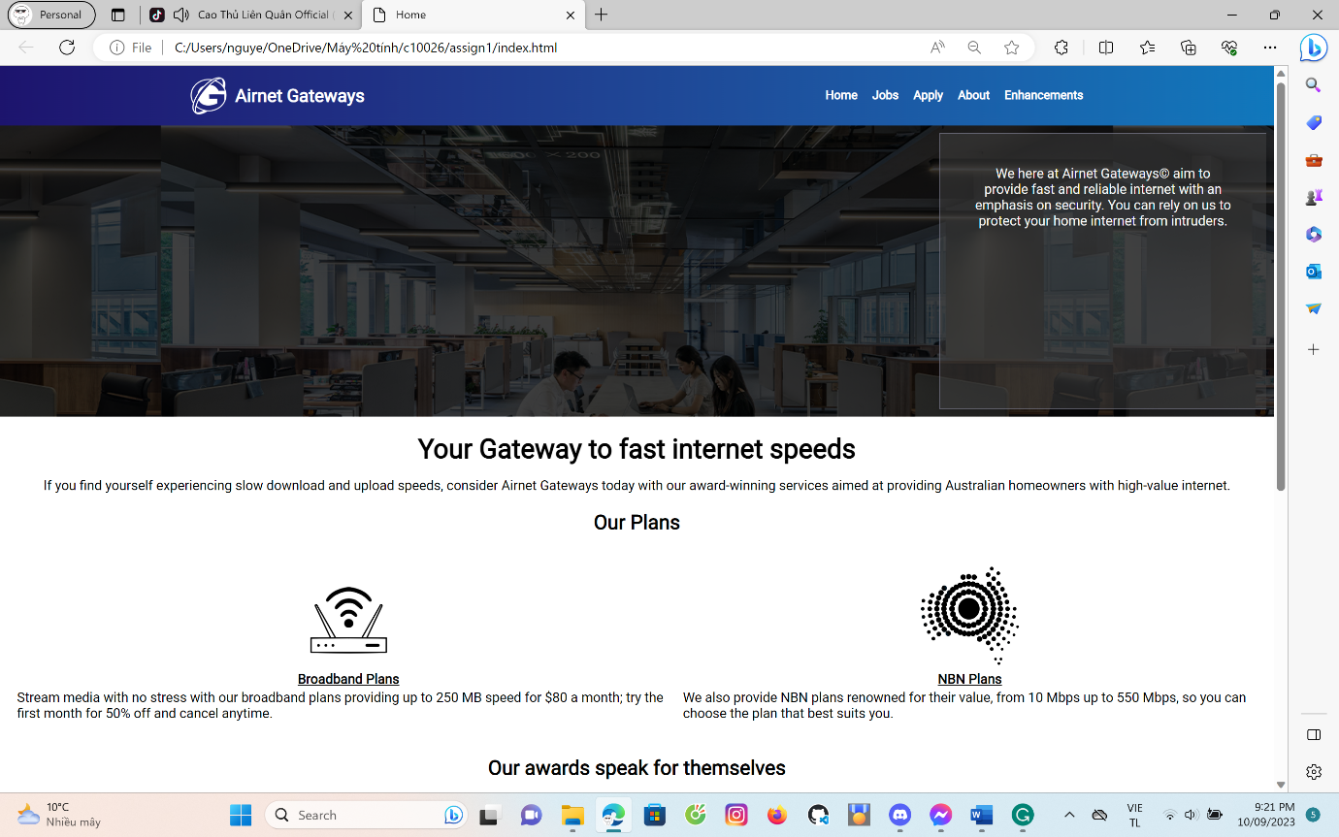

*Image: Home page(index.html)*

For the navigation bar, to make the animation appear when the mouse hovers over it, we use ::hover and ::after pseudo-classes. When we designed this animation, we added the color after the bar hovered to indicate where the mouse was hovering over and make it more reader-friendly. We apply the 'Roboto' font to the website since many websites use this font.

We also apply the @media query to ensure the flow of the websites will be displayed correctly on different devices (for tablets and phones) for reaching users worldwide, no matter what devices they are using to surf these webpages.

*Image: Footer of Home page*

## Jobs

*Image: Job description page (jobs.html)*

There is also an effect on this page: the color of the 'apply now' button turned darker when the mouse hovers over it. Also, when the users click the questions in the 'FAQ' section, it slides down the answers, which makes it livelier.

The website's color is mainly white in the body section and dark blue in the header and footer sections so that there is a contrast between the colors of each section. Also, the navigation bar and the logo in the header are white, and the content color is black to make the content of each section contrast with the background.

*Image 5: Footer of the job description page*

## Apply

*Image 6: Application form page (apply.html)*

I used black, white, and dark blue colors to enhance the color contrast so that the users can be impressed by the website's style.

I have also implemented some minor animations and features to make the websites more interactive by adding the 'submit' and 'reset' button-hovering effects, as mentioned previously.

*Image 7: Remain part of the job application page.*

## About

*Image 8: About page (about.html)*

There are two main sections of information: one for the whole group and the other for each member. The page displays information by putting the photos of the members and their information underneath. Also, after including all the members, there is a timetable that my teammate, Hizqeel, styled to have a one-lined border.

*Image 8: Footer of the About page (about.html)*

## Enhancements

*Image 9: Enhancement Page (enhancements.html)*

The enhancements page is styled by putting the information required on the top and then putting the images indicating where we applied those enhancements underneath.

*Image 10: footer of Enhancement Page*

# Key Features

The website's essential features comprise a combination of its appeal and effectiveness. Noticeably, its responsive design serves to increase its adaptability, rendering it accessible on a multitude of devices. Incorporating subtle animations on the navigation bar enhances its aesthetic user engagement. These features collectively contribute to an immersive and engaging user experience. The color is dark blue due to the inspiration from the blue logo of Telstra.

# Contribution and Reflection

Throughout the development journey, my contributions spanned various stages of the project. I designed and developed the job application page, selecting images and CSS styling. I also gave suggestions to other members' pages and drafted the enhancement page. Moreover, I help them set dates for each stage of development, ensure they follow the instructions and stay caught up on the deadline, and remind them to check the work after finishing.

Throughout the process of creating a website, many challenges appeared, including providing alt text for images and using adequate color contrast to achieve consistent harmony in the website's layout. While the challenges are significant obstacles to overcome, they push me to break my limit to not only meet the requirements but to enhance the website effectively with great teamwork and the knowledge provided by the lectures and the Internet.

# Conclusion

Based on the innovative features and enhancements throughout this report, I have shown evidence that my teammates and I have put a lot of effort and attention into creating an attractive and user-friendly website. It also was implemented with several unique features to boost the user's experience, including using CSS animations to make it more attractive.

We could include more enhancements in the future to have more interactivity by incorporating multimedia content, enhancing accessibility features, refining search functionality, and integrating social media capabilities to facilitate content sharing.

This report has provided a comprehensive overview of the website, covering aspects ranging from its content, style, and critical features to accessibility considerations, contributions, challenges, and highlights.

# References

Transitions: W3Schools (n.d.). CSS. <https://www.w3schools.com/css/css3_transitions.asp>

Buttons: W3Schools (n.d.). CSS. <https://www.w3schools.com/csS/css3_buttons.asp>

Media queries: W3Schools (n.d.). CSS. [CSS Media Queries (w3schools.com)](https://www.w3schools.com/css/css3_mediaqueries.asp)

(Centre for Accessibility Australia, n.d.)